Innovative Renewable Technologies and their Role in Climate Change Mitigation of Rural Areas in Bihar

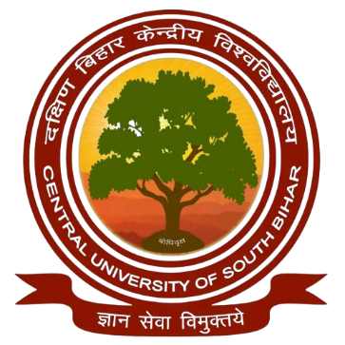

A dissertation to be submitted to
Central University of South Bihar
In fulfilment of the requirements for the degree of
MASTER OF SCIENCE
submitted by
RAJAK DEEPU KUMAR
CUSB2303212020
in
ENVIRONMENTAL SCIENCE
under the supervision of
Prof. Pradhan Parth Sarthi

Department of Environmental Science
School of Earth, Biological and Environmental Sciences
Central University of South Bihar, Gaya Ji, India - 824236
(2023 – 2025)

